COMMEMORATION OF THE INTERNATIONAL ANTI-CORRUPTION DAY AND LAUNCH OF THE NATIONAL ANTI-CORRUPTION STRATEGY (NACS II)

As the World was commemorating the International Anti-Corruption Day on Monday, 9th December, Malawi commemorated the day by among other things launching the National Anti-Corruption Strategy (NACS II) and the Strategic Plan for the Anti-Corruption Bureau (ACB). These two strategic documents had undergone reviews that will guide the nation and the ACB in the fight against corruption.

The International Anti-Corruption Day this year in Malawi was commemorated under the theme MY FIGHT; OUR FIGHT, CORRUPTION MUST FALL while the United Nations settled for UNITED AGAINST CORRUPTION. Both themes are calling for concerted efforts in dealing with corruption.

Launching the NACS II and the Strategic Plan was the Minister of Justice and Constitutional Affairs Honourable Bright Msaka, SC, who was the guest of honour during the commemoration. Other dignitaries who spoke on the day are the British High Commissioner Ms. Holly Tett, and the Director General of the ACB, Mr. Reyneck Matemba. The key message on the day was for all Malawians to join hands with the ACB if the war against corruption is to be won. Also, in attendance was the presidential adviser on Governance, Dr. Chris Daza.

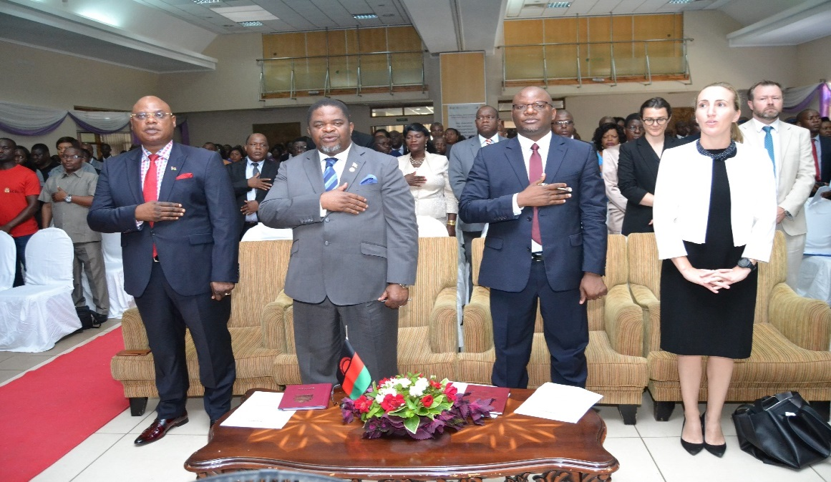
The Guest of honour and other dignitaries singing the Malawi National Anthem
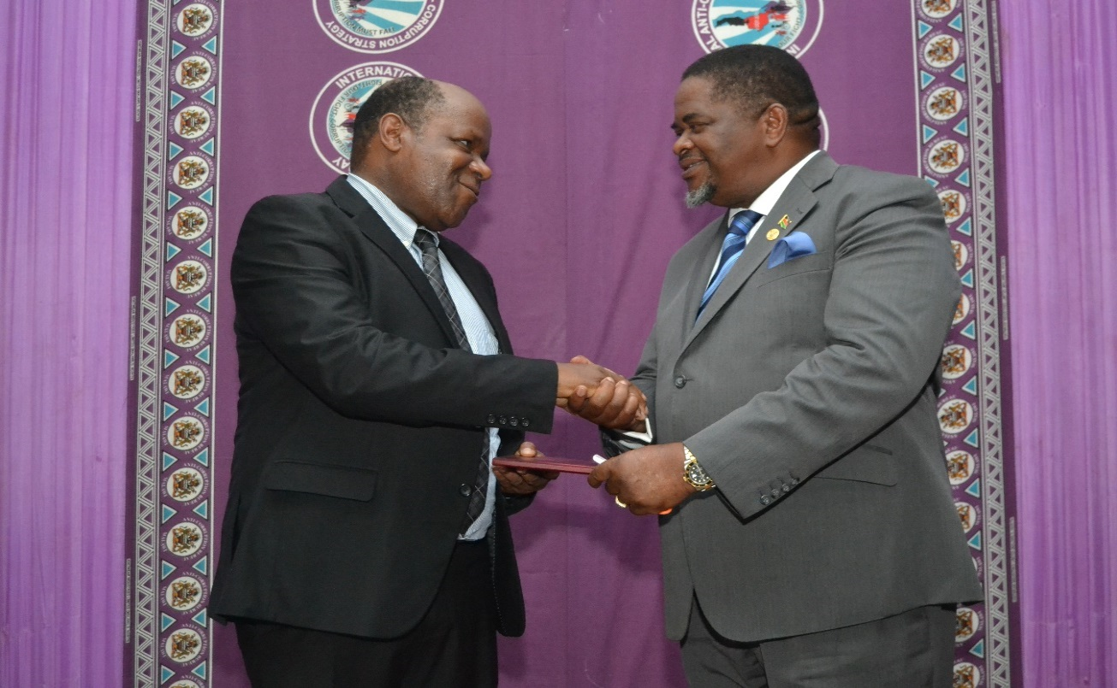
The Minister of Justice and Constitutional Affairs Hon. Bright Msaka, SC, hands the NACS II to the Chairperson of the Oversight Committee Mr. Alifeyo Banda.
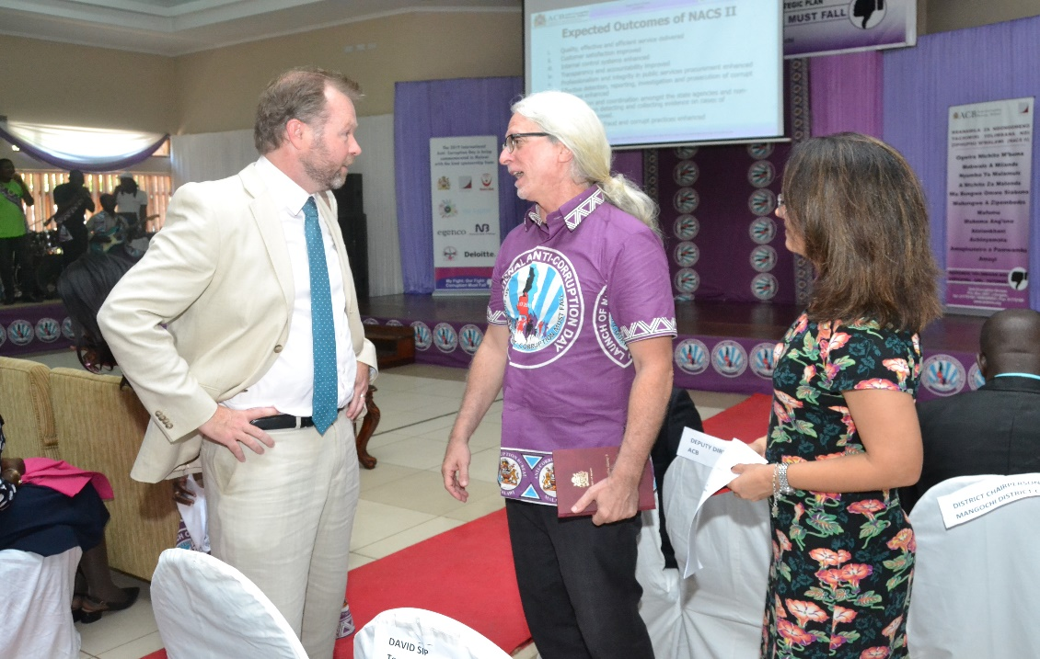
Some of the representatives from the Department for International Development and Basel Institute on Governance who provided technical assistance in the review of the NACS were also present at the launch.

After the launch, the real work will have to be carried out by implementing the NACS within the next five years. It is hoped that the various stakeholders will play their rightful role and implement the strategies under their respective pillars.

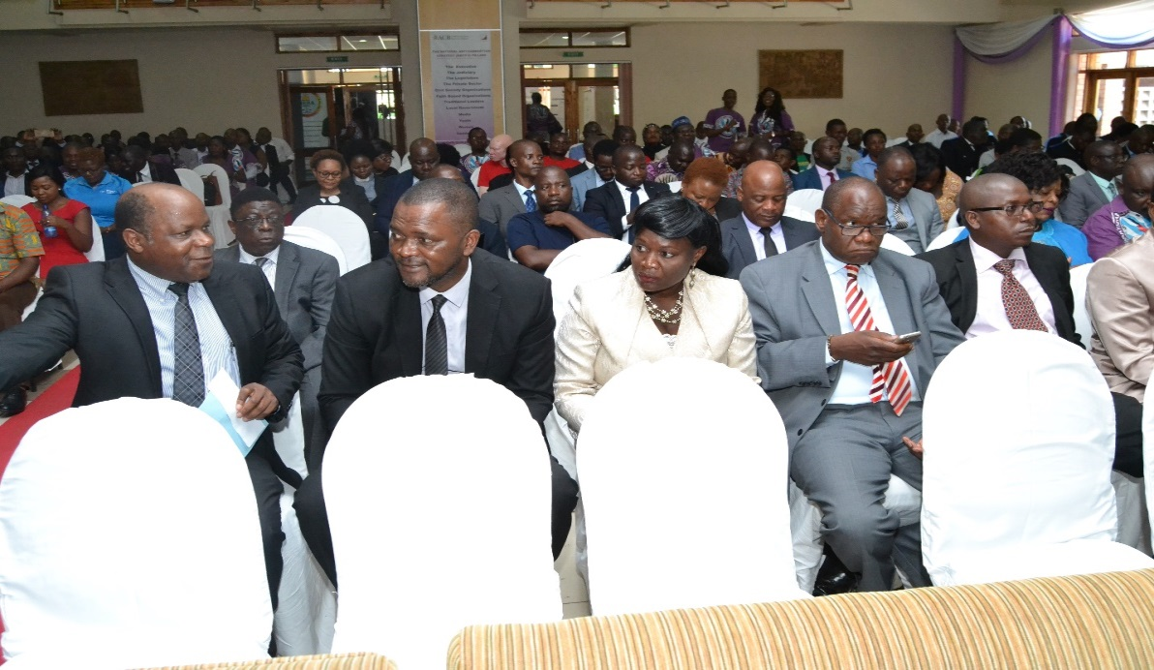
From left to right Mr. Alifeyo Banda, Chairman of the Oversight Committee and other members seated during the commemoration and launch.

