
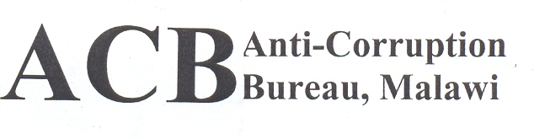
Tel:Tel: +265 (0) 1 770 166 +265 (0) 1 770 130
Fax:+265 (0) 1 774 585
e-mail: anti-corruption@acbmw.org P.O. Box 2437
Lilongwe
Malawi

CLIENT SATISFACTION QUESTIONNAIRE
Introduction
This survey questionnaire has been developed in order to solicit your views about the services the Bureau offers. The responses that you give will be treated with confidentiality and you are not required to indicate your name. Your responses will be solely used to improve service delivery of the Bureau.

Instructions: Tick or fill where necessary.
- Sex
Male Female

- Age
Under 18 18-35 36-59 60 –above

- Level of education
None Primary Secondary Tertiary

- State the purpose of your visit to the Bureau
Complaint reporting Bail reporting Official business If others, state…………………………………
- How many times have you visited the Bureau?
Once/ first time Twice Several
- How were you received at our Front Desk Office/Reception?
Excellent Good Fair Poor Very Poor

- If your answer in 6 above is not excellent or good, please explain

- Service satisfaction
- Which section of the bureau did you Visit? ( Please tick against the section which you visited In the table below)
Section | Tick
Report Centre
Documentation
Investigations
Prosecutions
Public Education
Corruption Prevention
Public Relations
Internal Audit
Finance
Human Resources
Administration
Procurement & Stores
Information Technology
Monitoring & Evaluation

- How long did it take before you were served in the section that you visited?
5 minutes
10 minutes
20 minutes
30 minutes
More than 30 minutes

- Were you satisfied with the time you spent to obtain the service
Very satisfied
Satisfied
Somewhat satisfied
Unsatisfied
Very unsatisfied

- How would you rate the officer/(s) who attended to you?
Professional Somewhat professional Unprofessional

- Were you satisfied with the service offered?
Very satisfied
Satisfied
Somewhat satisfied
Unsatisfied
Very unsatisfied

- How did you know about the services of the Bureau?
Radio
Newspaper
Friends
Website
Rallies by ACB
If others, state……………………………………………………….
- Do you think services of the Bureau are easily accessible?

Yes No

If No explain.

- Do you think the Bureau is doing enough to combat corruption in Malawi?

Yes No

If No explain

- Is there anything you would want the Bureau to improve?

Thank you for taking your time and sharing your opinions.

